***Section* 2.8 – Applications**

**Motion with Resistance Proportional to Velocity**

An object with a mass ***m*** is moving along a coordinate line with position function ***s*** and velocity ***v*** at time ***t***.

From ***Newton’s second law*** of motion, the resistance force opposing the motion is



If the resisting force is proportional to velocity, we have



This is a separable differential equation, the solution with initial condition  is



In the English system, where the weight is measured in pounds, mass is measured in slugs. Thus,



***Example***

For a 192-*lb* ice skater, the ***k*** is about  slug/sec and . How long will it take the skater to coast from 11 *ft/sec* (7.5 *mph*) to 1 *ft/sec*? How far will the skater coast before coming to a complete stop?

***Solution***

 









Distance 

**Mixtures Problems**

The physical representation of the rate of change:

*rate of change = rate in* - *rate out*

This is referred to as a ***balance law***.

Rate = Volume Rate (*gal/min*) *x* Concentration (*lb/gal*)

If  is the amount of chemical in the container at time *t* and  is the total volume of liquid in the container at time *t*, then the departure rate of the chemical at time *t* is





***Example***

In an oil refinery, a storage tank contains 2,000 *gal* of gasoline that initially has 100 *lb*. of an additive dissolved in it. In preparation for winter weather, gasoline containing 2 *lb*. of additive per gallon is pumped into the tank at a rate of 40 *gal/min*. The well-mixed solution is pumped out at a rate of 45 *gal/min*. How much of the additive is in the tank 20 *min* after the pumping process begins?

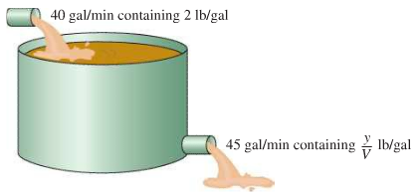

***Solution***

Let *y* be the amount (in *lb*.) of additive in the tank at time *t* and 

















 

































**RL Circuits**

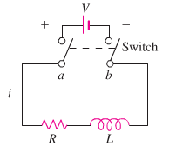

The diagram represents an electrical circuit whose total resistance is a constant ***R*** ohms and whose self-inductance is coil, is ***L*** henries.

***Ohm’s Law***: 



***i***: current in amperes

***t***: time in seconds

***Example***

The switch in the *RL* circuit is closed at time *t* = 0. How will the current flow as a function of time?

***Solution***

























The current approaches the ***steady-state value*** .

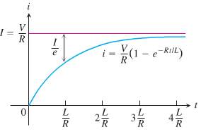

***Exercises Section* 2.8 – Applications**

1. A 66-*kg* cyclist on a 7-*kg* bicycle starts coasting on level ground at 9 *m/sec*. The 
2. About how far will the cyclist coast before reaching a complete stop?
3. How long will it take the cyclist’s speed to drop to 1 *m/sec*?
4. Suppose that an Iowa class battleship has mass 51,000 metric tons (51,000,000 *kg*) and . Assume that the ship loses power when it is moving at a speed of 9 *m/sec*.
5. About how far will the ship coast before it is dead in the water?
6. About how long will it take the ship’s speed to drop to 1 *m/sec*?
7. A 200-*gal* tank is half full of distilled water. At time *t* = 0, a solution containing 0.5 *lb./gal* of concentrate enters the tank at the rate of 5 *gal/min*, and the well-stirred mixture is withdrawn at the rate of 3 *gal/min*.
8. At what time will the tank be full?
9. At the time the tank is full, how many pounds of concentrate will it contain?
10. A tank contains 100 *gal* of fresh water. A solution containing 1 *lb./gal* of soluble lawn fertilizer runs into the tank at the rate of 1 *gal/min*, and the mixture is pumped out of the tank at a rate of 3 *gal/min*. Find the maximum amount of fertilizer in the tank and the time required to reach the maximum.
11. An Executive conference room of a corporation contains 4500  of air initially free of carbon monoxide. Starting at time *t* = 0, cigarette smoke containing 4% carbon monoxide is blown into the room at the rate of 0.3 . A ceiling fan keeps the air in the room well circulated and the air leaves the room at the same rate of 0.3 . Find the time when the concentration of carbon monoxide in the room reaches 0.01%.
12. Many chemical reactions are the result of the interaction of 2 molecules that undergo a change to produce a new product. The rate of the reaction typically depends on the concentrations of the two kinds of molecules. If *a* is the amount of substance *A* and *b* is the substance *B* at time *t* = 0, and if *x* is the amount of product at time *t*, then the rate of formation of *x* may be given by the differential equation



Where *k* is a constant for the reaction. Integrate both sides of this equation to obtain a relation between *x* and *t*.

1. If 
2. If 

Assume in each case that  when 

1. The tank initially holds 100 *gal* of pure water. At time , a solution containing 2 *lb* of salt per gallon begins to enter the tank at the rate of 3 gallons per minute. At the same time a drain is opened at the bottom of the tank so that the volume of solution in the tank remains constant.

How much salt is in the tank after 60 *min*?

What will be the eventual salt content in the tank?

1. The 600-*gal* tank is filled with 300 *gal* of pure water. A spigot is opened above the tank and a salt solution containing 1.5 *lb*. of salt per gallon of solution begins flowing into the tank at the rate of 3 *gal/min*. Simultaneously, a drain is opened at the bottom of the tank allowing the solution to leave tank at a rate of 1 *gal/min*. What will be the salt content in the tank at the precise moment that the volume of solution in the tank is equal to the tank's capacity (600 *gal*)?
2. A tank with a 2,000 *gal* capacity initially contains 500 *gal* of brine containing 100 *lbs*. of salt starting at time *t* = 0, brine containing 0.1 *lb/gal* of salt is added at a rate of 60 *gal/min* and the mixed solution is drained off at a rate of 40 *gal/min*. How much salt is in the tank when it reaches the point of over flowing?
3. The amount of drug in the blood of a patient (in *mg*) due to an intravenous line is governed by the initial value problem



Where *t* is measured in hours

1. Find and graph the solution of the initial value problem.
2. What is the steady-state level of the drug?
3. When does the drug level reach 90% of the steady-state value?
4. A fish hatchery has 500 *fish* at time , when harvesting begins at a rate of *b* *fish/yr*. where . The fish population is modeled by the initial value problem.



Where *t* is measured in years.

1. Find the fish population for  in terms of the harvesting rate *b*.
2. Graph the solution in the case that . Describe the solution.
3. Graph the solution in the case that . Describe the solution.
4. A community of hares on an island has a population of 50 when observations begin at . The population for  is modeled by the initial value problem.



1. Find the solution of the initial value problem.
2. What is the steady-state population?
3. When an infected person is introduced into a closed and otherwise healthy community, the number of people who become infected with the disease (in the absence of any intervention) may be modeled by the logistic equation



Where *k* is a positive infection rate, *A* is the number of people in the community, and  is the number of infected people at . The model assumes no recovery or intervention.

1. Find the solution of the initial value problem in terms of *k*, *A*, and .
2. Graph the solution in the case that  .
3. For fixed values of *k* and *A*, describe the long-term behavior of the solutions for any  with 
4. An object of mass ***m*** is released from a balloon. Find the distance it falls in ***t*** seconds, if the force of resistance due to the air is directly proportional to the speed of the object.
5. A body falls from a height of 300 *ft*. What distance has it traveled after 4 *sec*. if subject to *g*, the earth’s acceleration?
6. A body falls from an initial velocity of . What distance has it traveled after 3 *sec*. if subject to, the earth’s acceleration?
7. A projectile is fired straight upwards with an initial velocity of . What is its velocity at . 
8. A projectile is fired straight upwards with an initial velocity of . What is its velocity at . 
9. A stone is released from rest and dropped into a deep well. Eight seconds later, the sound of the stone splashing into the water at the bottom of the well returns to the ear of the person who released the stone. How long does it take the stone to drop to the bottom of the well? How deep is the well? Ignore air resistance. The speed of sound is 340 *m/s*.
10. A rocket is fired vertically and ascends with constant acceleration  for 1.0 *min*. At that point, the rocket motor shuts off and the rocket continues upward under the influence of gravity. Find the maximum altitude acquired by the rocket and the total time elapsed from the take-off until the rocket returns to the earth. *Ignore air resistance*.
11. A ball is projected vertically upward with initial velocity from ground level. Ignore air resistance.
12. What is the maximum height acquired by the ball?
13. How long does it take the ball to reach its maximum height? How long does it take the ball to return to the ground? Are these times identical?
14. What is the speed of the ball when it impacts with the ground on its return?
15. An object having mass 70 *kg* falls from rest under the influence of gravity. The terminal velocity of the object is . Assume that the air resistance is proportional to the velocity.
16. Find the velocity and distance traveled at the end of 2 *seconds*.
17. How long does it take the object to reach 80% of its terminal velocity?
18. An object in free fall may be modeled by assuming that the only forces at work are the gravitational force and resistance (friction due to the medium in which the objects falls). By Newton’s second law (mass × acceleration = the sum of the external forces), the velocity of the object satisfies the differential equation



Where  is a function that models the resistance and the positive direction is downward. One common assumption (often used for motion in air) is that , where  is a drag coefficient.

1. Show that the equation can be written in the form  where 
2. For what (positive) value of *v* is  (This equilibrium solution is called the ***terminal velocity***.)
3. Find the solution of this separable equation assuming  for 
4. Graph the solution found in part (***c***) with , and verify the terminal velocity agrees with the value found in part (***b***).
5. An open cylindrical tank initially filled with water drains through a hole in the bottom of the tank according to Torricelli’s Law. If  is the depth of water in the tank for , then Torricelli’s Law implies  , where *k* is a constant that includes the acceleration due to gravity, the radius of the tank, and the radius of the drain. Assume that the initial depth of the water is 

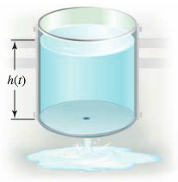

1. Find the solution of the initial value problem.
2. Find the solution in the case that  and .
3. In general, how long does it take the tank to drain in terms of *k* and *H*?
4. The reaction of chemical compounds can often be modeled by differential equations. Let  be the concentration of a substance in reaction for  (typical units of *y* are *moles/L*). The change in the concentration of a substance, under appropriate conditions, is , where  is a rate constant and the positive integer *n* is the order of the reaction.
5. Show that for a first-order reaction , the concentration obeys an exponential decay law.
6. Solve the initial value problem for a second-order reaction  assuming 
7. Graph and compare the concentration for a first-order and second-order reaction with  and 
8. The consumption of a substrate in a reaction involving an enzyme is often modeled using Michaelis-Menton Kinetics, which involves the initial value problem , , where  is the amount of substrate present at time , and *Q* and *K* are positive constants. Solve the initial value problem with , , and . Notice that the solution can be expressed explicitly only with *t* as a function of *s*. Describe how *s* behaves as .
9. An investment account, which earns interest and has regular deposits, can be modeled by the initial value problem  for , with . The constant *a* reflects the monthly interest rate, *m* is the rate of monthly deposits, and is the initial balance in the account. Solve the initial value problem with , , and . After how many months does the account have a balance of $7,500?
10. The growth of cancer turmors may be modeled by the Gomperts growth equation. Let  be the mass of the tumor for . The relevant intial value problem is



Where *a* and *K* are positive constants and 

1. Graph the growth rate function  assuming  and . For what values of *M* is the growth rate positive? For what values of *M* is maximum?
2. Solve the initial value problem and graph the solution for , , and . Describe the growth pattern of the tumor. Is the growth unbounded? If not, what is the limiting size of the tumor?
3. In the general equation, what is the meaning of *K*?
4. An endowment is an investment account in which the balance ideally remains constant and withdrawals are made on the interest earned by the account. Such an account may be modeled by the initial value problem  for , with . The constant *a* reflects the annual interest rate, *m* is the annual rate of withdrawal, and is the initial balance in the account.
5. Solve the initial value problem with  and . Does the balance in the account increase or decrease?
6. If  and , what is the annual withdrawal rate *m* that ensures a constant balance in the account? What is the constant balance?
7. The halibut fishery has been modeled by the differential equation 

Where  is the biomass (the total mass of the members of the population) in kilograms at time *t* (measured in years), the carrying capacity is estimated to be  and .

1. If , find the biomass a year later.
2. How long will it take for the biomass to reach .
3. Suppose a population  satisfies  where *t* is measured in *years*.
4. What is the carrying capacity?
5. What is ?
6. When will the population reach 50% of the carrying capacity?
7. Let  be the performance level of someone learning a skill as a function of the training time *t*. The graph of *P* is called a ***learning curve***. We proposed the differential equation



As a reasonable model for learning, where *k* is a positive constant. Solve it as a linear differential equation and use your solution to graph the learning curve.

1. An inductor  and a resistor  are joined in series with an electronic force (emf)  and no charge on the capacitor at . Find the ensuing charge current in the current at time *t* for the given 
2. An inductor  and a resistor  are joined in series with an electronic force (*emf*)  and no charge on the capacitor at . Find the ensuing current in the current at time *t* for the given 
3. An inductor  and a resistor  are joined in series with an electronic force (*emf*)  and no charge on the capacitor at . Find the ensuing current in the current at time *t* for the given 
4. An *RL* circuit with a  resistor and a  inductor is driven by a voltage . If the initial inductor current is zero, determine the subsequence resistor and inductor current and the voltages.
5. An *RL* circuit with a  resistor and a  inductor is driven by a voltage . If the initial inductor current is 1 *A*, determine the subsequence resistor and inductor current and the voltages.
6. For the given *RL*−circuit

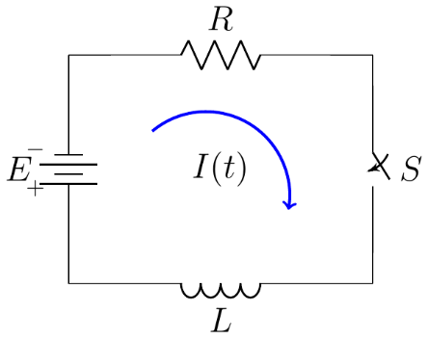

Which has a constant impressed voltage *E*, a resistor of resistance *R*, and a coil of impedance *L*.

Find the current  flowing in the circuit.

1. For the given *RL*−circuit

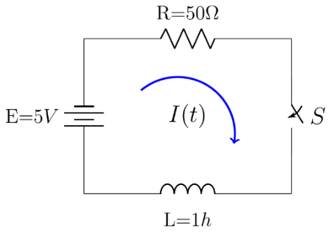

Which has a constant impressed voltage *E*, a resistor of resistance *R*, and a coil of impedance *L*.

Find the current  flowing in the circuit.

1. 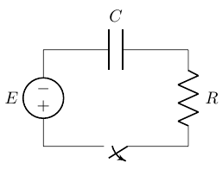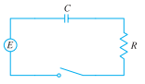A circuit containing an electromotive force, a capacitor with a capacitance of *C* farads (*F*), and a resistor with a resistance of *R* ohms . The voltage drop across the capacitor is , where *Q* is the charge (in coulombs), so in this case ***Kirchhoff’s Law*** gives



But , so we have 

Find the charge and the current at time *t*

1. Suppose the resistance is , the capacitance is 0.05 *F*, a battery gives voltage of 60 *V* and initial charge is 
2. Suppose the resistance is , the capacitance is 0.01 *F*,  and initial charge is 
3. A 30−volt electromotive force is applied to an *LR*-series circuit in which the inductance is 0.1 *henry* and the resistance is 50 *ohms*.
4. Find the current  if 
5. Determine the current as 
6. Solve the equation when  and 
7. A tank contains 50 *gallons* of a solution composed of 90% water and 10% alcohol. A second solution containing 50% water and 50% alcohol is added to the tank at the rate of . As the second solution is being added, the tank is being drained at a rate of . The solution in the tank is stirred constantly. How much alcohol is in the tank after 10 *minutes*?

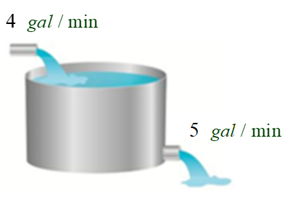

1. A 200-*gallon* tank is half full of distilled water. At time , a concentrate solution containing  enters the tank at the rate of , and well-stirred mixture is withdrawn at the rate of .

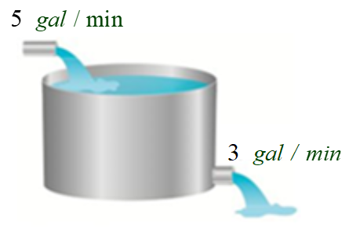

1. At what time will the tank be full?
2. At the time the tank is full, how many pounds of concentrate will it contain?
3. A 200-*gallon* tank is half full of distilled water. At time , a concentrate solution containing  enters the tank at the rate of , and well-stirred mixture is withdrawn at the rate of .



1. At what time will the tank be full?
2. At the time the tank is full, how many pounds of concentrate will it contain?
3. A 200-*gallon* tank is full of a concentrate solution containing . Starting at time , distilled water is admitted to the tank at the rate of , and well-stirred mixture is withdrawn at the same rate.

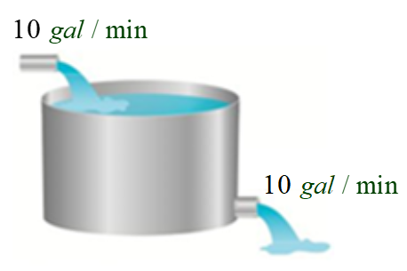

1. Find the amount of concentrate in the solution as a function of *t*.
2. Find the time at which the amount of concentrate in the tank reaches 15 pounds.
3. Find the quantity of the concentrate in the solution as .
4. A tank contains 300 *litres* of fluid in which 20 *grams* of salt is dissolved. Brine containing 1 *g* of salt per *litre* is then pumped into the tank at a rate of 4 *L/min*; the well-mixed solution is pumped out at the same rate. Find the number  of grams of salt in the tank at time *t*.

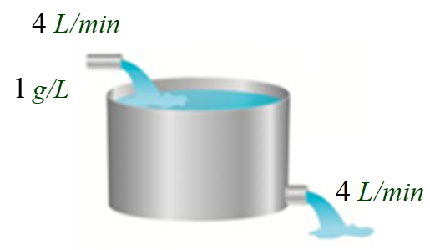

1. A 1500 *gallon* tank initially contains 600 *gallon* of water with 5 *lbs*. of salt dissolved in it. Water enters the tank at a rate of 9 *gal/hr.* and the water entering the tank at a rate has a salt concentration of  *lbs./gal*. If a well mixed solution leaves the tank at a rate of 6 *gal/hr.*, how much salt is in the tank when it overflows?
2. A tank contains 100 *gal* of pure water. At time zero, a sugar-water solution containing 0.2 *lb* of sugar per gal enters the tank at a rate of 3 *gal/min*. Simultaneously, a drain is opened at the bottom of the tank allowing the sugar solution to leave the tank at 3 *gal/min*. Assume that the solution in the tank is kept perfectly mixed at all times.

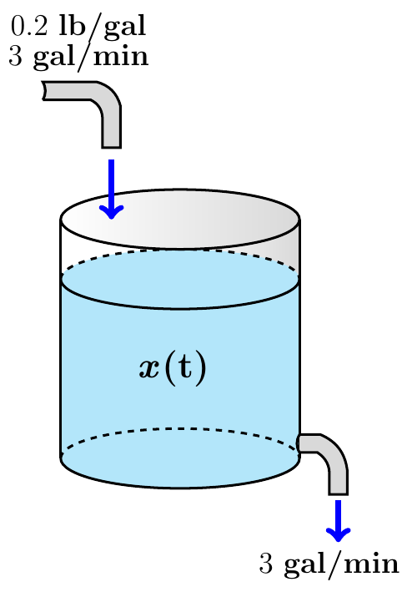

1. What will be the sugar content in the tank after 20 *minutes*?
2. How long will it take the sugar content in the tank to reach 15 *lbs*?
3. What will be the eventual sugar content in the tank?
4. A tank initially contains 50 *gal* of sugar water having a concentration of 2 *lbs*. of sugar for each gal of water. At time zero, pure water begins pouring into the tank at a rate of 2 *gal* per *minute*. Simultaneously, a drain is opened at the bottom of the tank so that the volume of sugar-water solution in the tank remains constant.

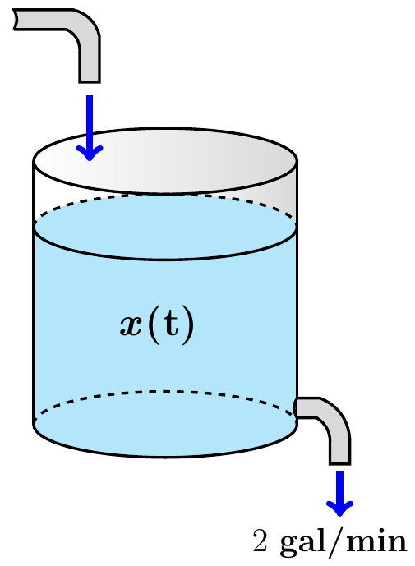

1. How much sugar is in the tank after 10 *minutes*?
2. How long will it take the sugar content in the tank to dip below 20 *lb*.?
3. What will be the eventual sugar content in the tank?
4. Suppose that in the cascade tank 1 initially 100 *gal* of pure ethanol and tank 2 initially contains 100 *gal* of pure water. Pure water flows into tank 1 at 10 *gal/min*, and the other two flow rates are also 10 *gal/min*.

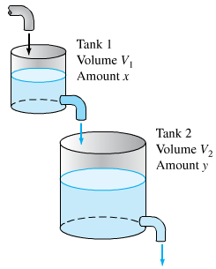

1. Find the amounts  and  of ethanol in the two tanks at time  .
2. Find the maximum amount of ethanol ever in tank 2.